HTML SIMPLE EXERCISES

1. **HTML Text formatting exercises**
2. Print the squares of the numbers 1 - 20. Each number should be on a separate line, next to it the number 2 superscripted, an equal sign and the result.
3. Print two lists with any information you want. One list should be an ordered list, the other list should be an unordered list
4. Prints an h1 level heading followed by a horizontal line whose width is 100%. Below the horizontal line print a paragraph relating to the text in the heading.
5. Print a definition list with 5 items
6. Print two addresses in the same format used on the front of envelopes (senders address in top left corner, receivers address in the center)
7. Print ten acronyms and abbreviations of your choosing, each separated by two lines. Specify the data that the abbreviations and acronyms represent
8. **HTML IMAGE EXERCISES**
9. Display five different images. Skip two lines between each image. Each image should have a title.
10. Display an image that has a border of size 2, a width of 200, and a height of 200.
11. Display the image towards the right corner of the webpage
12. **EQUATION EXERCISES**
13. Display the following equations in webpage

ax4+bx3+cX2+dx3+e=0

mXa+nyb+px5+qy2+cYb+5=0

1. **HTML LIST EXERCISES**
2. **Program to illustrate Nested list**

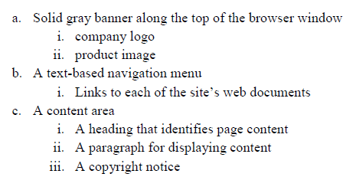

1. **Program to illustrate Nested list**

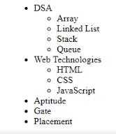

1. **Program to illustrate Nested list**

